GetCharFromString
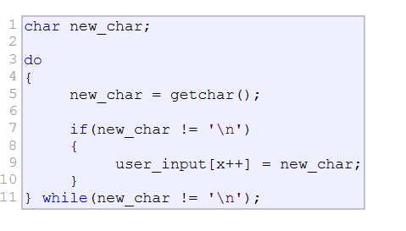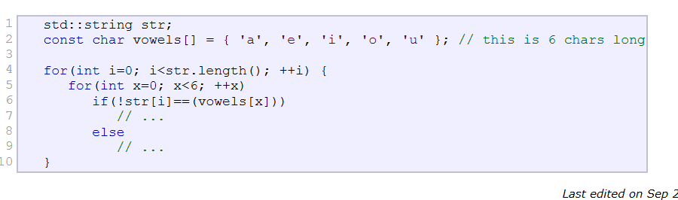
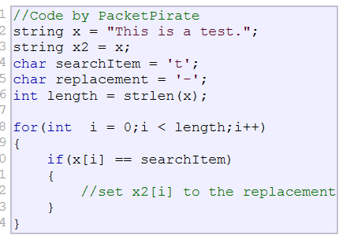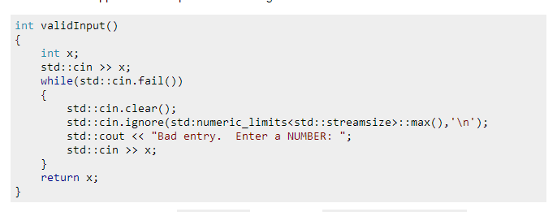/* atol example */
#include <stdio.h> /* printf, fgets */
#include <stdlib.h> /* atol */
using namespace std;
int main ()
{
long int li;
char buffer[256];
printf ("Enter a long number: ");
fgets (buffer, 256, stdin);
li = atol(buffer);
printf ("The value entered is %ld. Its double is %ld.\n",li,li*2);
return 0;
}
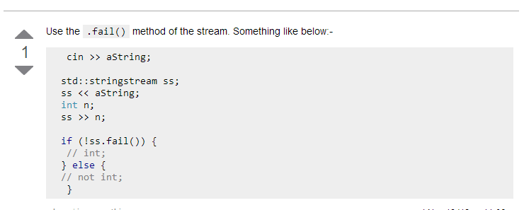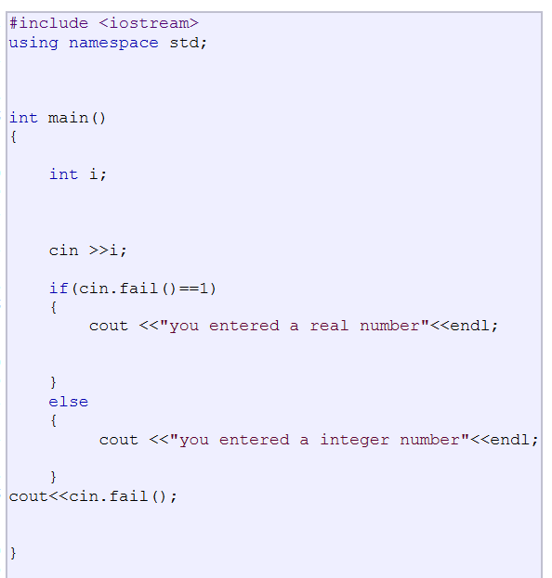
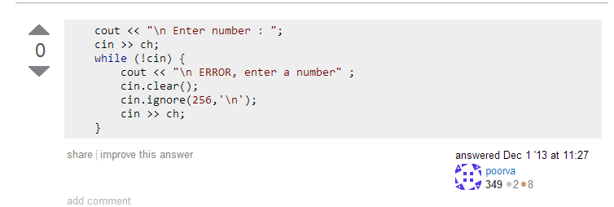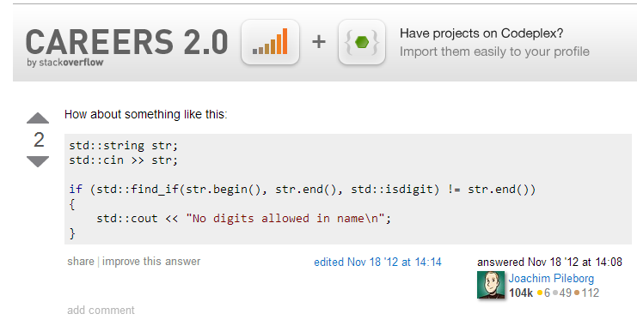
Check whether state of stream is good
Returns true if none of the stream's error state flags (eofbit, failbit and badbit) is set.
This function behaves as if defined as:
1  2  3 | bool ios::good() const {  return rdstate() == goodbit;  }

